1. **Agenda**: Suppose, we have a problem at a particular line inside a program and we want to identify what is the root cause for that problem.
2. **Scenario**:  
   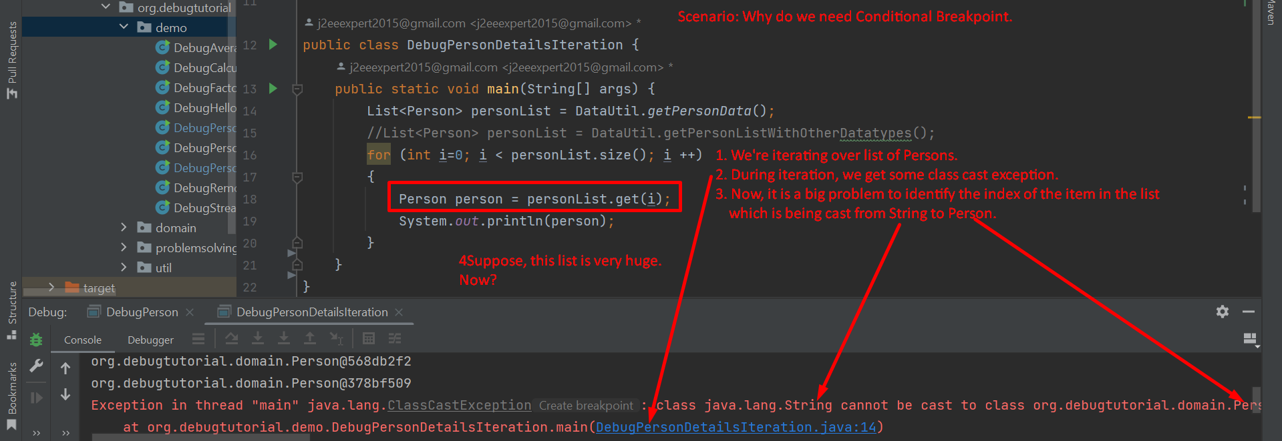
3. **Now question is how to put conditional breakpoint**
   1. **Step 01: Creating normal Breakpoint. In later step, we will convert into conditional breakpoint.**A picture containing text

      Description automatically generated
   2. **Step 02: Converting into conditional breakpoint.**  
      Graphical user interface

      Description automatically generated with medium confidence
   3. **Step 03:** Run the program and debug the code:  
      Text

      Description automatically generated with medium confidence